Internet applications

Assignment Five

23W LIB2024 010

Dr. Huthaifa Abderahman

Olivia McKeen

April 17, 2023

Table of contents Page 2

Introduction Page 3

Script blocks Page 3-5

Photographic evidence Page 5-19

Conclusion Page 19

Reference Page 20

Introduction

This assignment while a bit challenging was kind of fun. I really enjoyed that I could make it about whatever I wanted. I chose to make my website about the *Outlander series* by Diana Gabaldon. I found a navigation bar tutorial that I used to link all 5 pages together and created content for each page. Most of the information is from Diana Gabaldon but also my own personal opinions and some fake Latin as well to fill space. I found that linking the pages together was really hard before I found the tutorial. And I had a lot of trouble with the home page itself. Once I had all my buttons working on the navigation bar I started adding CSS to make the bar look nice and adding the rest of my information and images.

Script blocks

For this assignment, I figured out how to create a separate CSS document finally, so I put all elements of CSS there, I used similar parameters for each image and paragraph. For example, I created a div around images and paragraphs I wanted to keep together and I gave each image its own class and each div its own class therefore I could differentiate between the two wile also giving parameters to the image on its own and the paragraph. As shown below.

.side {

overflow: auto; /* to clear any floats inside the container */

}

.best {

border-radius: 50%;

border-style: double;

border-width:4px;

border-color: steelblue;

display: block;

width: 30%;

float: left;

padding: 15px;

margin: 10px;

}

This section is just for the navigation bar, I found a tutorial that gave a very nice-looking navigation bar and used that to link all my pages to. I changed the names of each page button, but I left the colour since teal is nice.

nav {

display: flex;

justify-content: space-around;

align-items: center;

min-height: 8vh;

background-color: teal;

font-family: helvetica, sans-serif;

}

.heading {

color: white;

text-transform: uppercase;

letter-spacing: 5px;

font-size: 20px;

}

.nav-links {

display: flex;

justify-content: space-around;

width: 30%;

}

.nav-links li {

list-style: none;

}

.nav-links a {

color: white;

text-decoration: none;

letter-spacing: 3px;

font-weight: bold;

font-size: 14px;

padding: 14px 16px;

}

.nav-links a:hover:not(.active) {

background-color: lightseagreen;

}

.nav-links li a.active {

background-color: #4caf50;

}

Photographic evidence

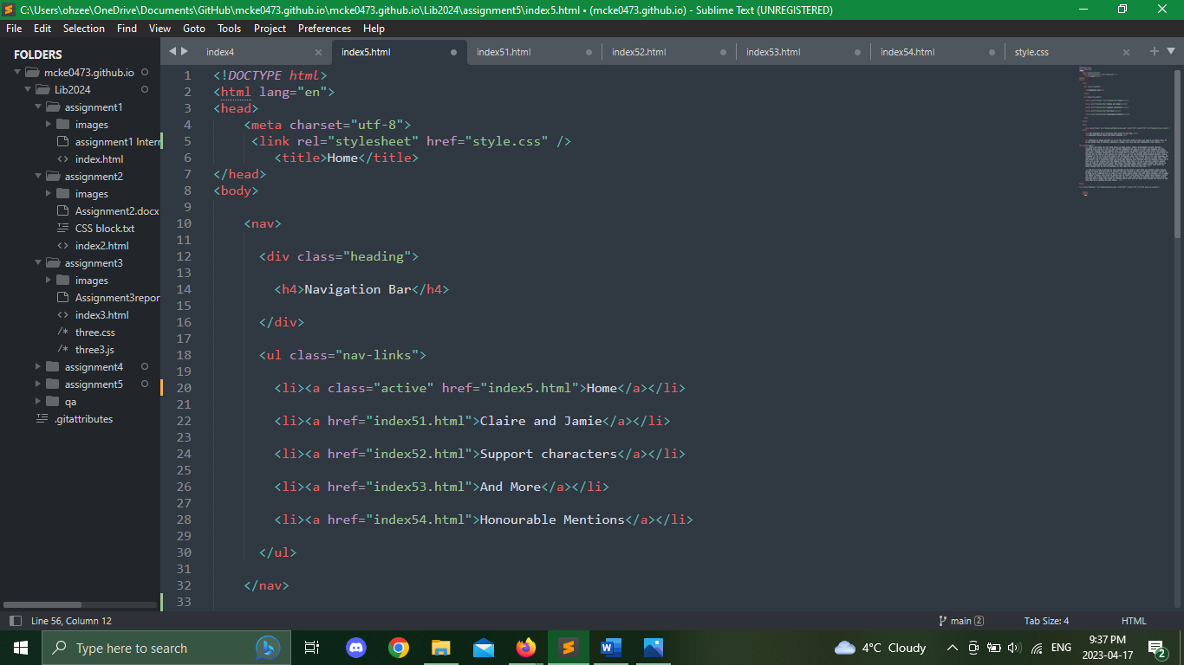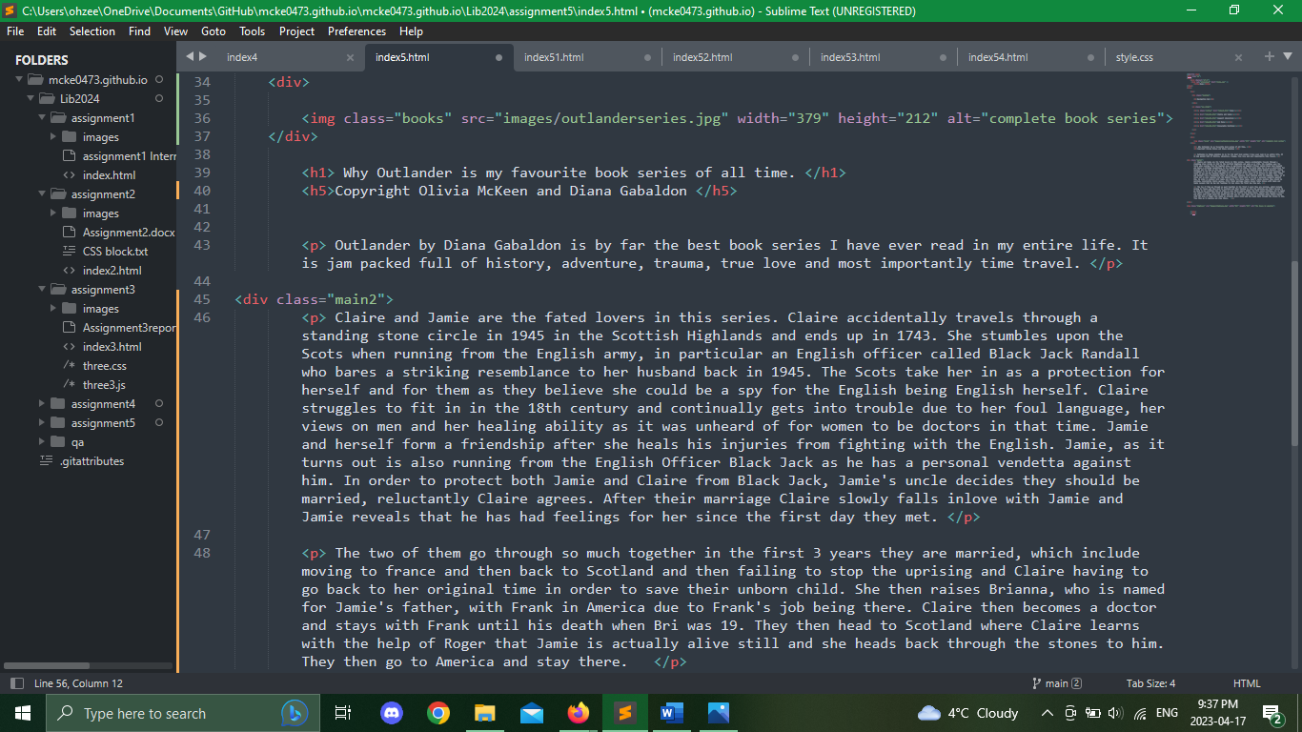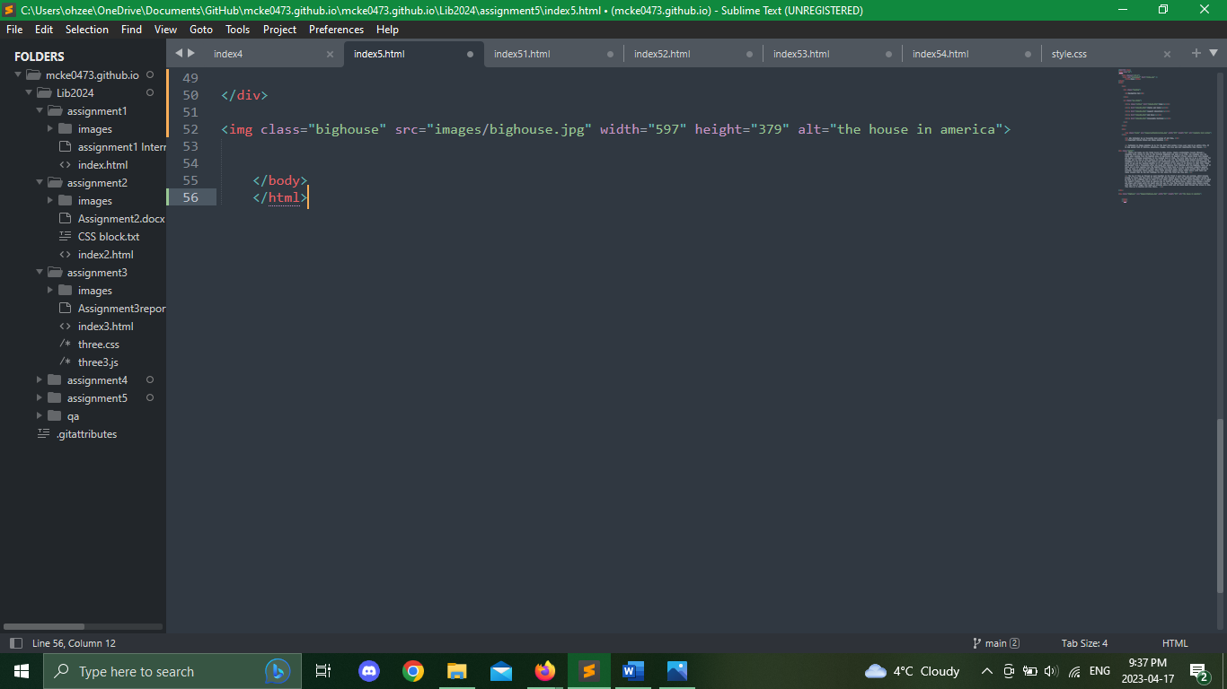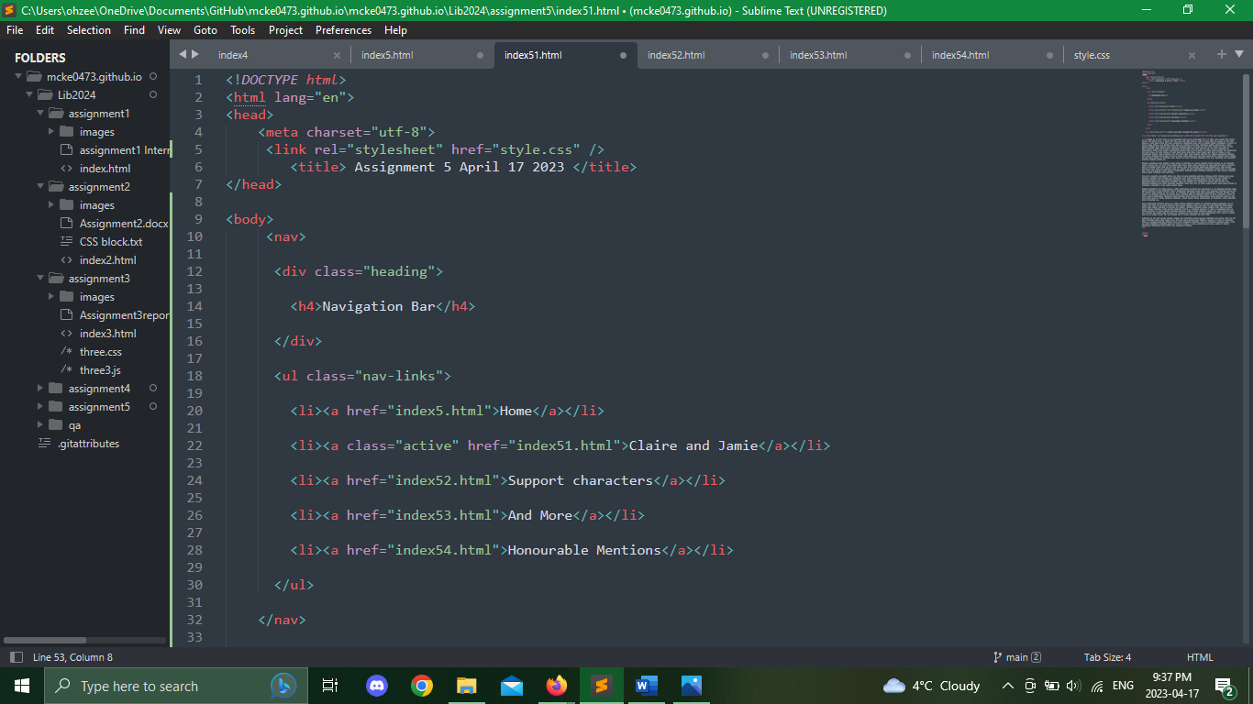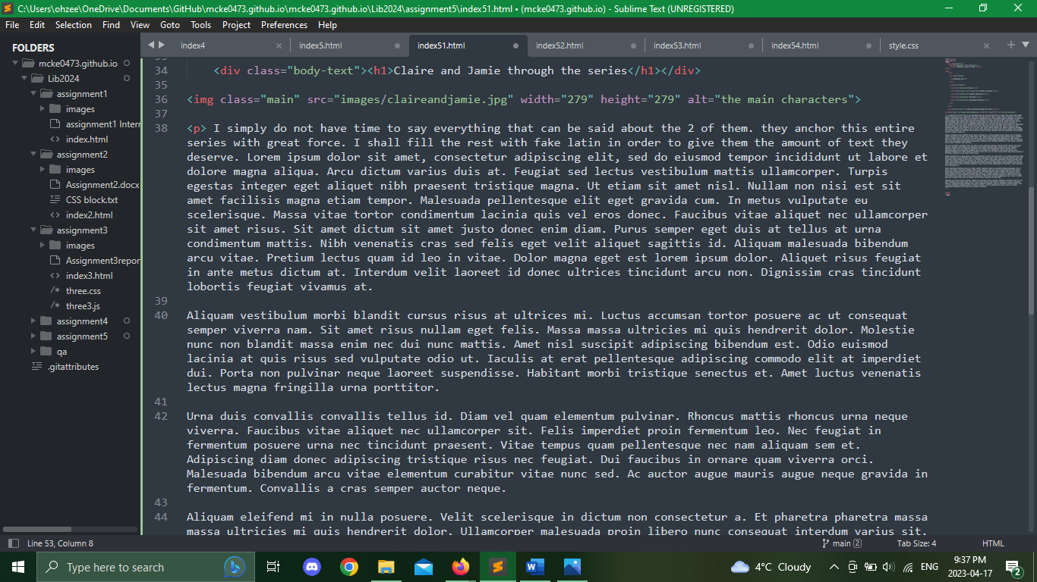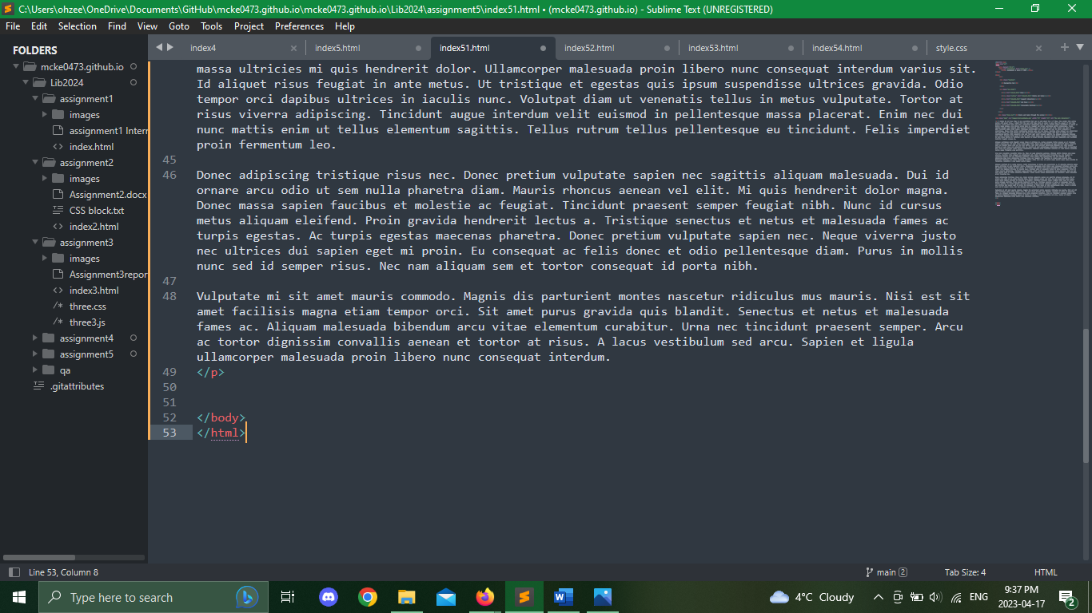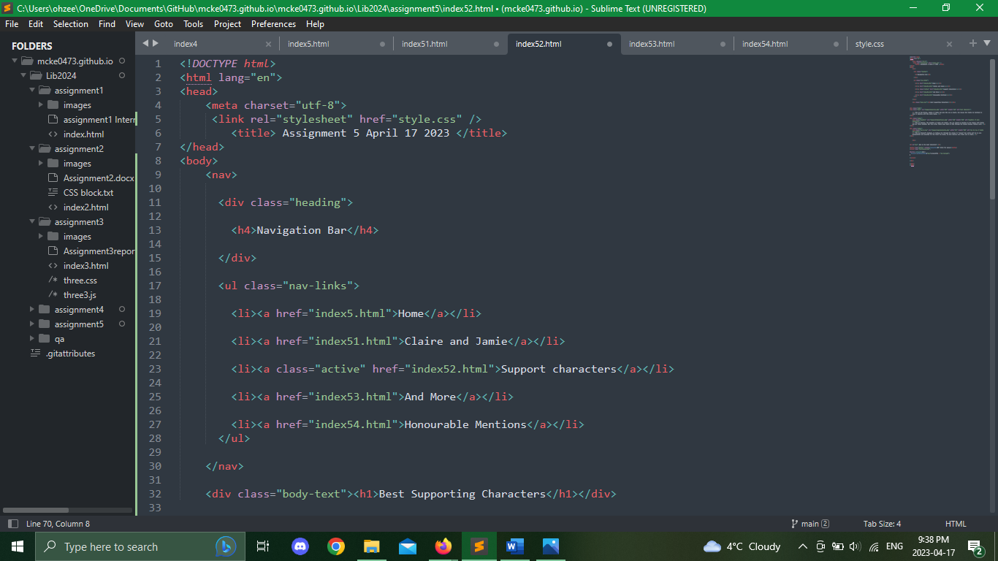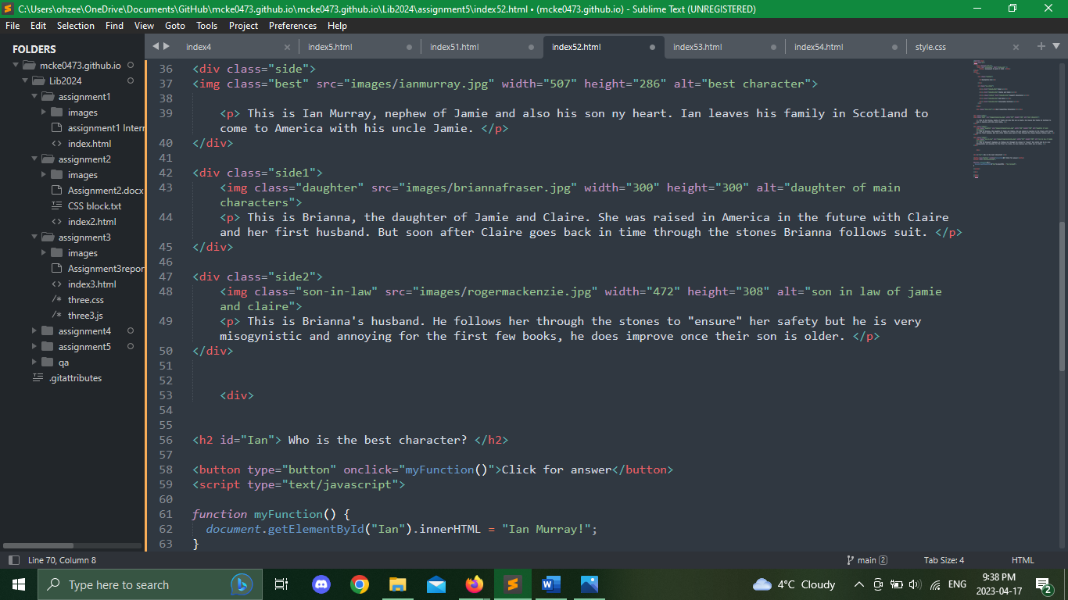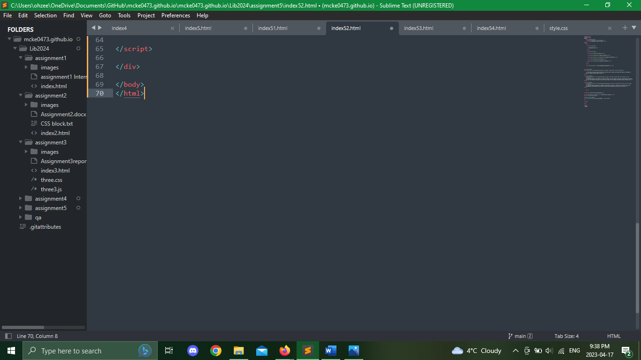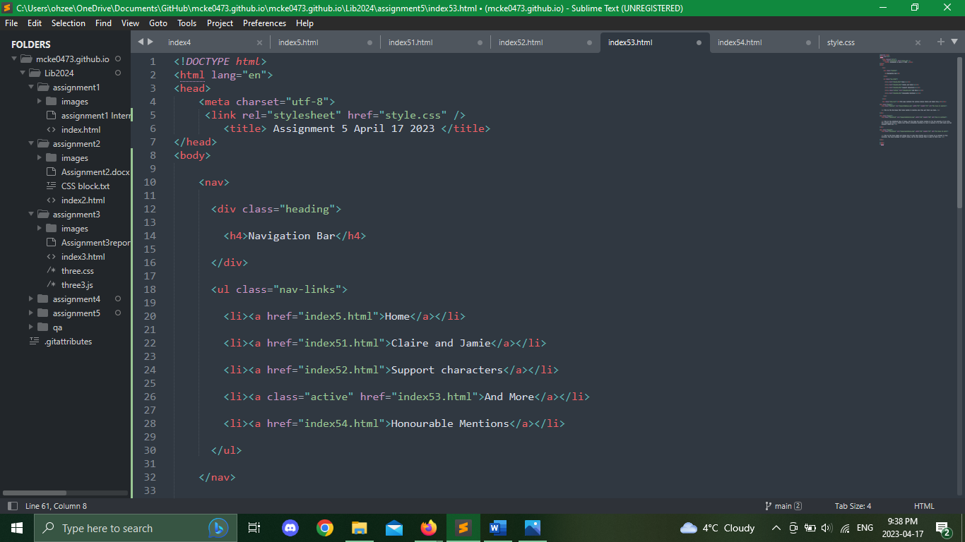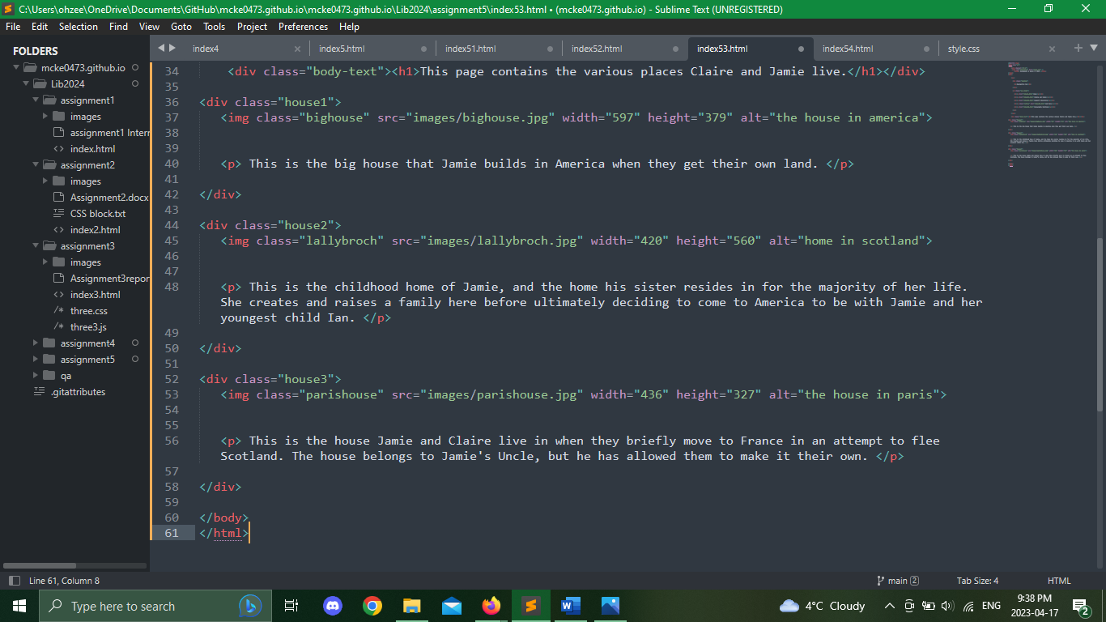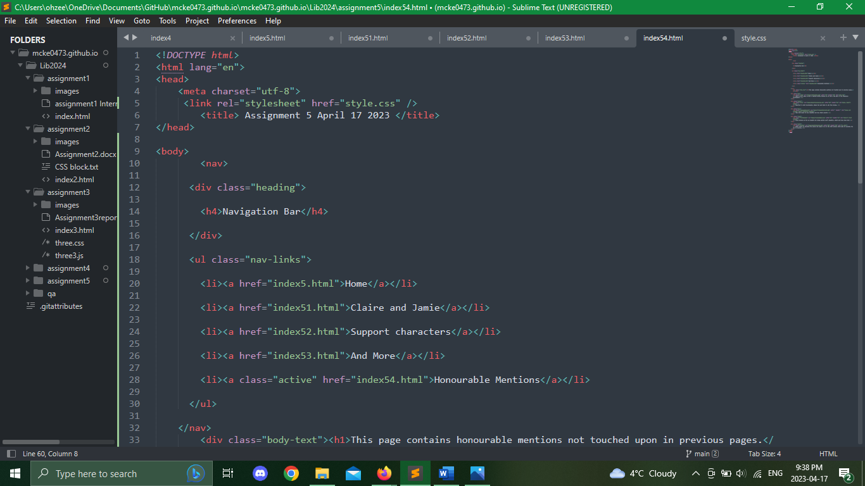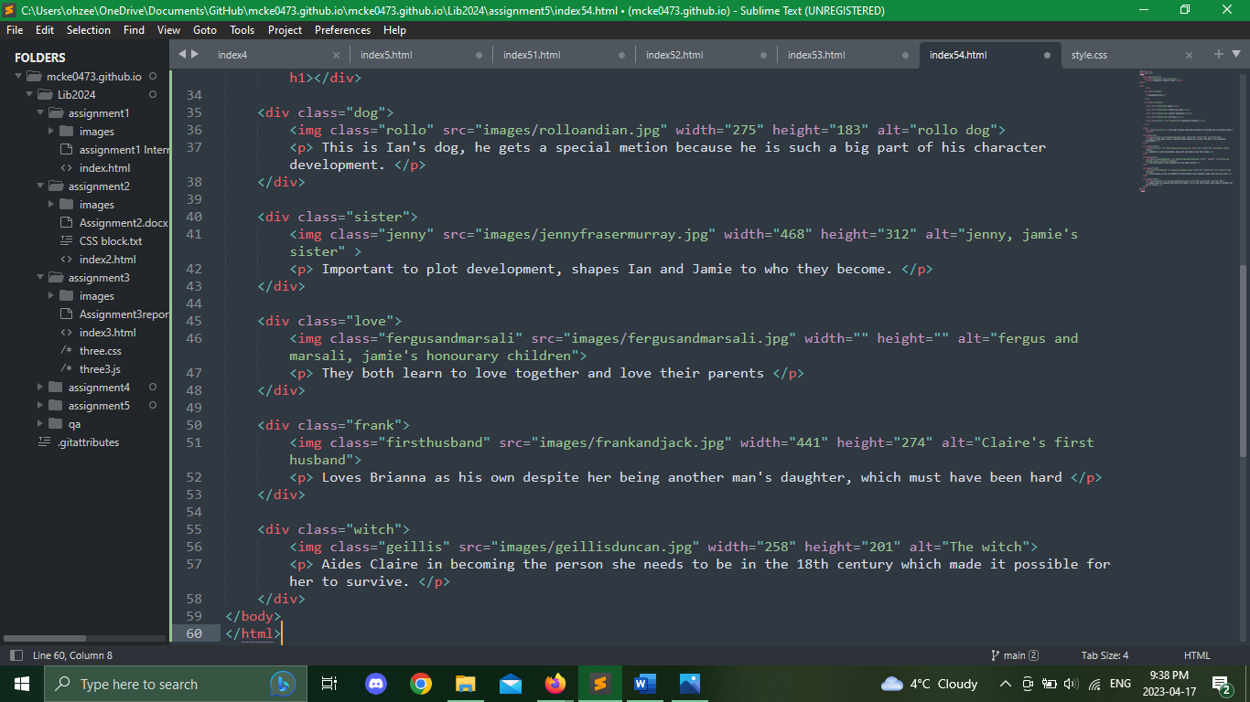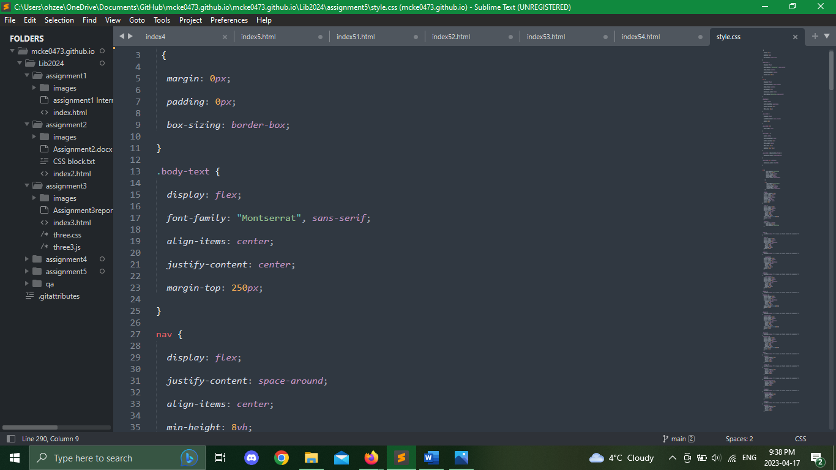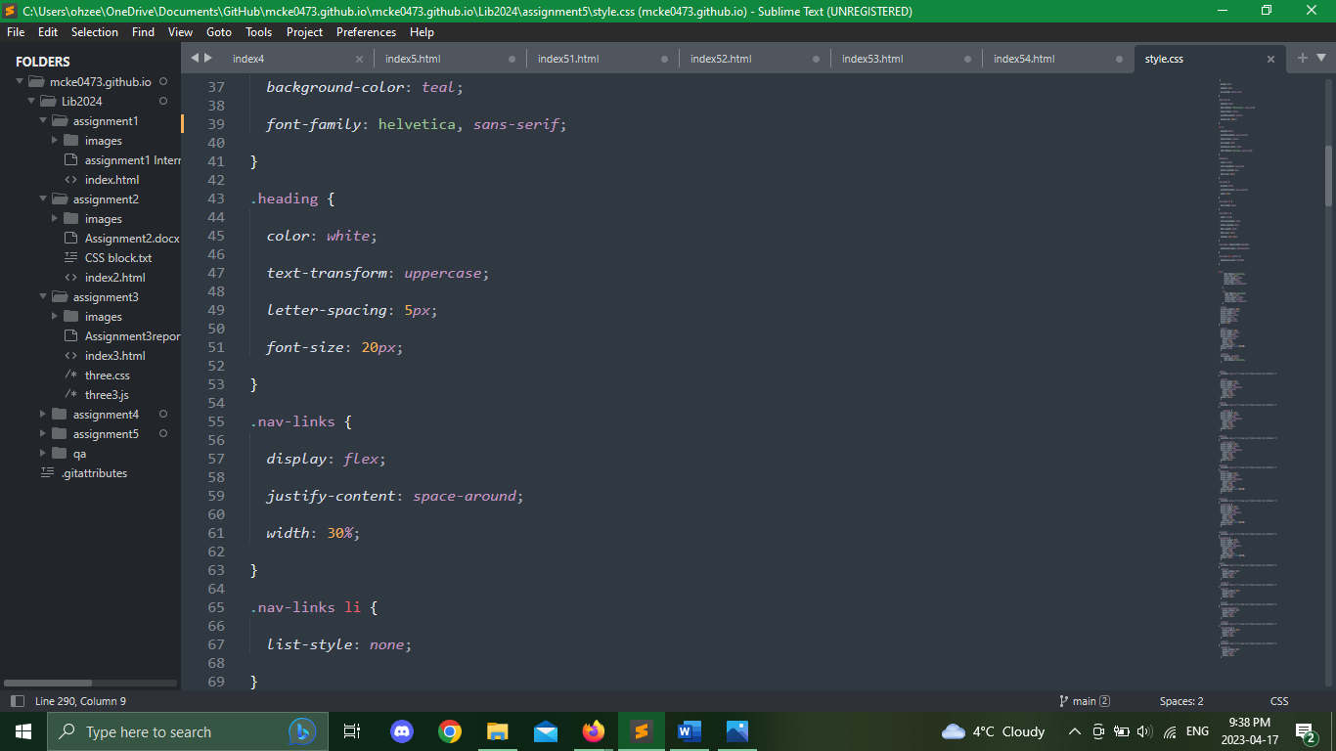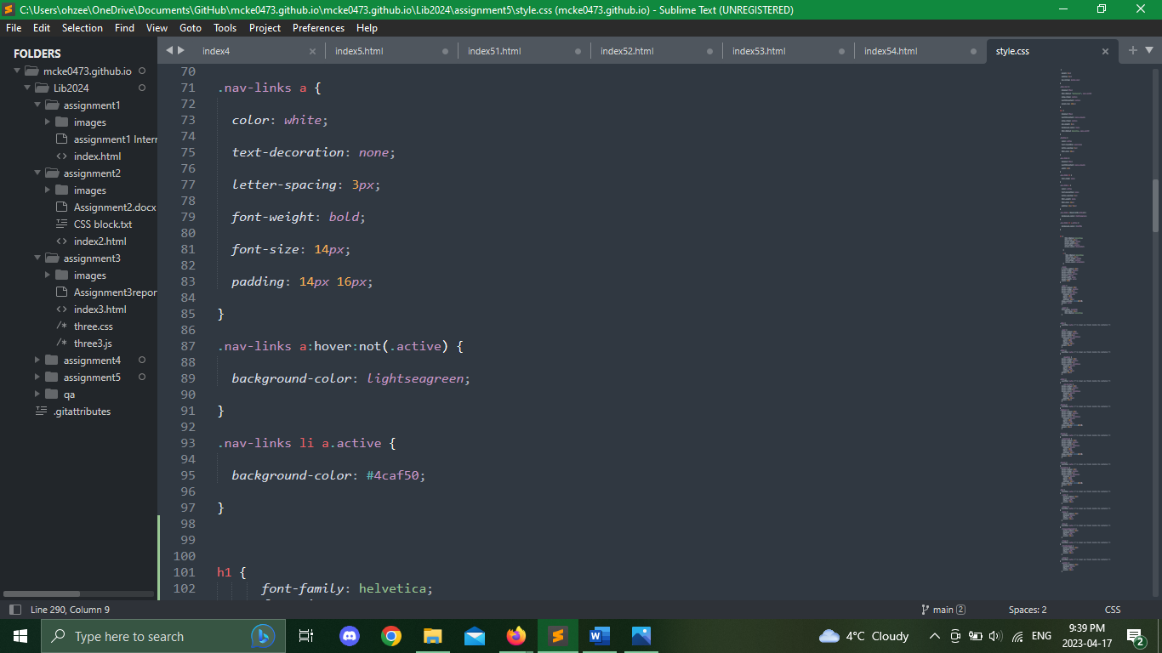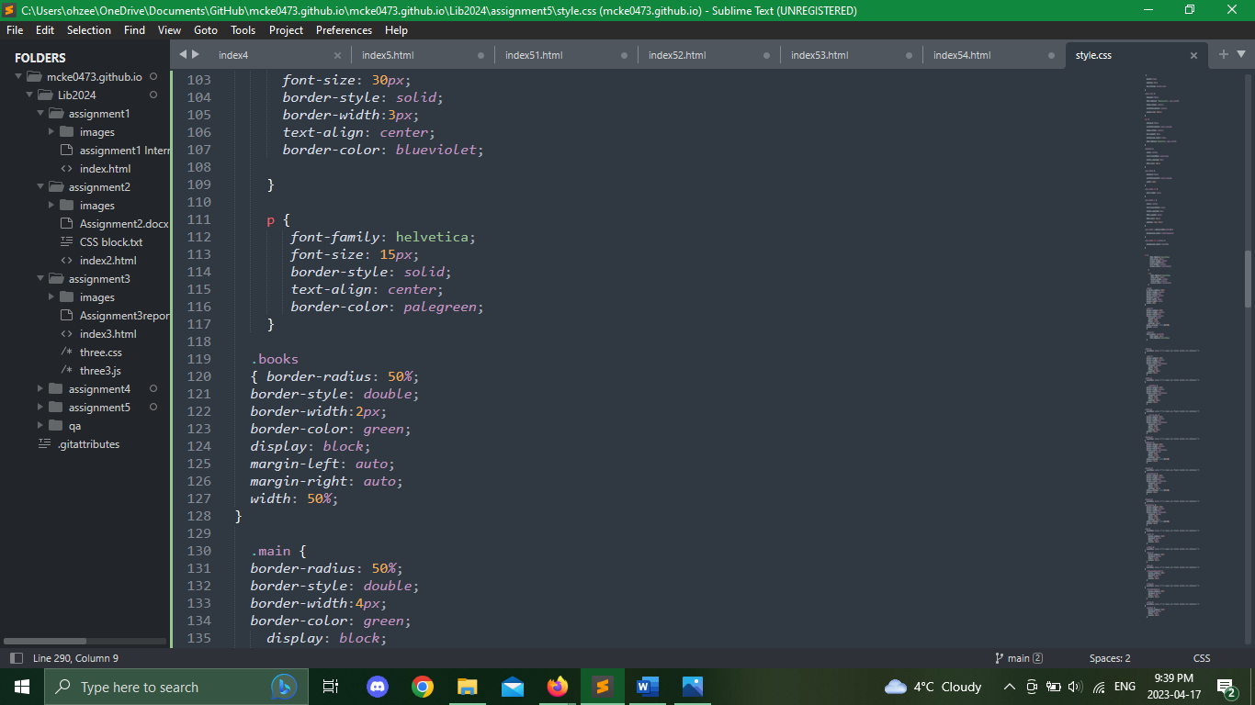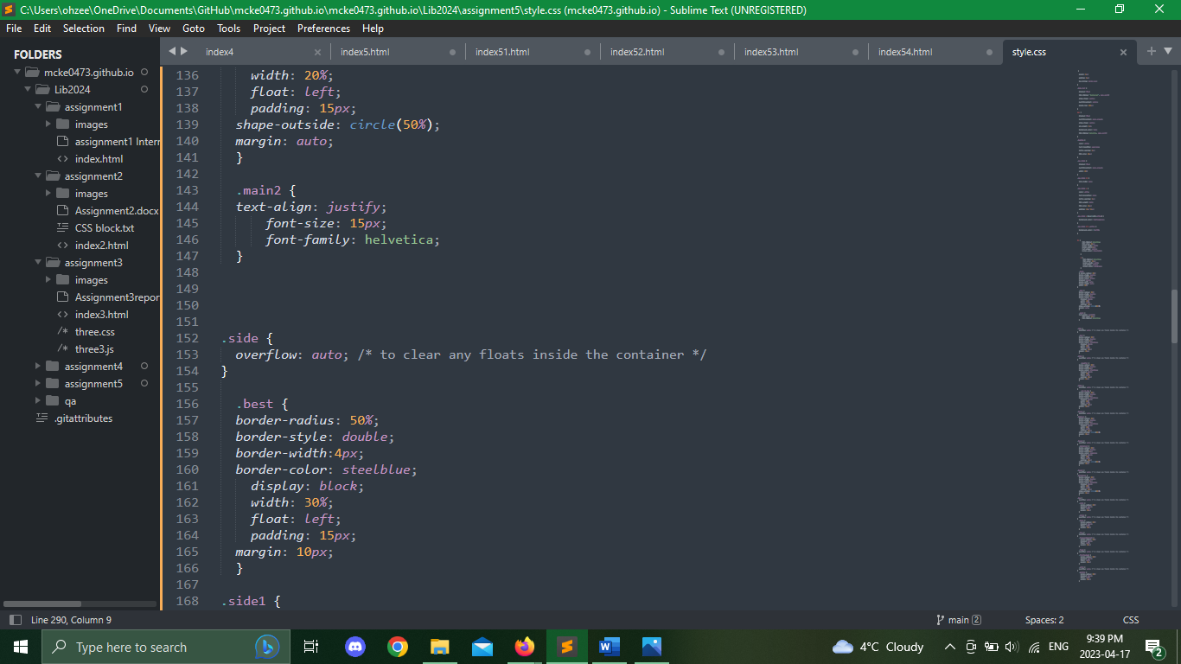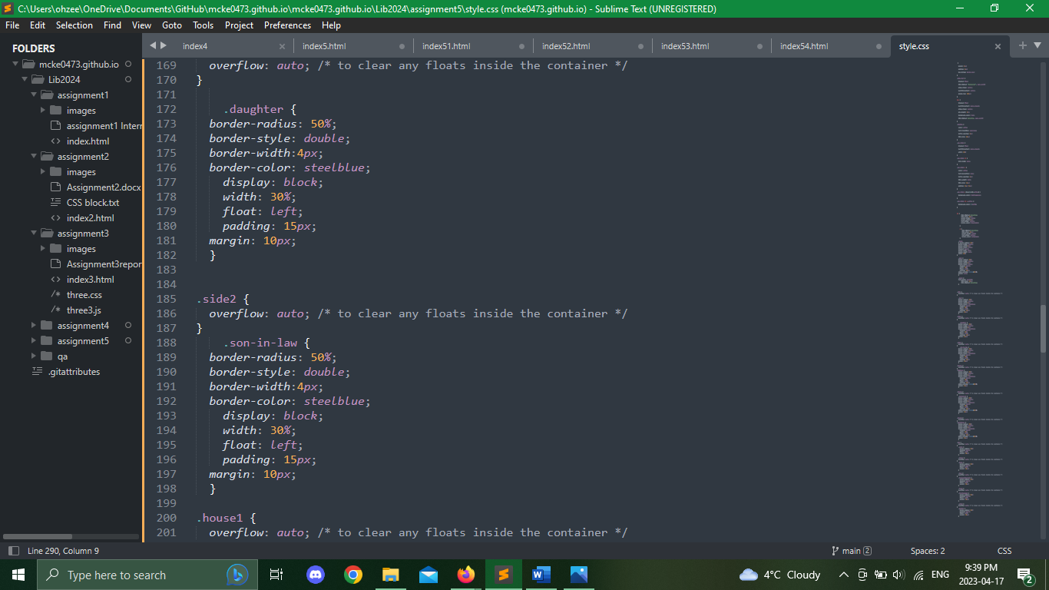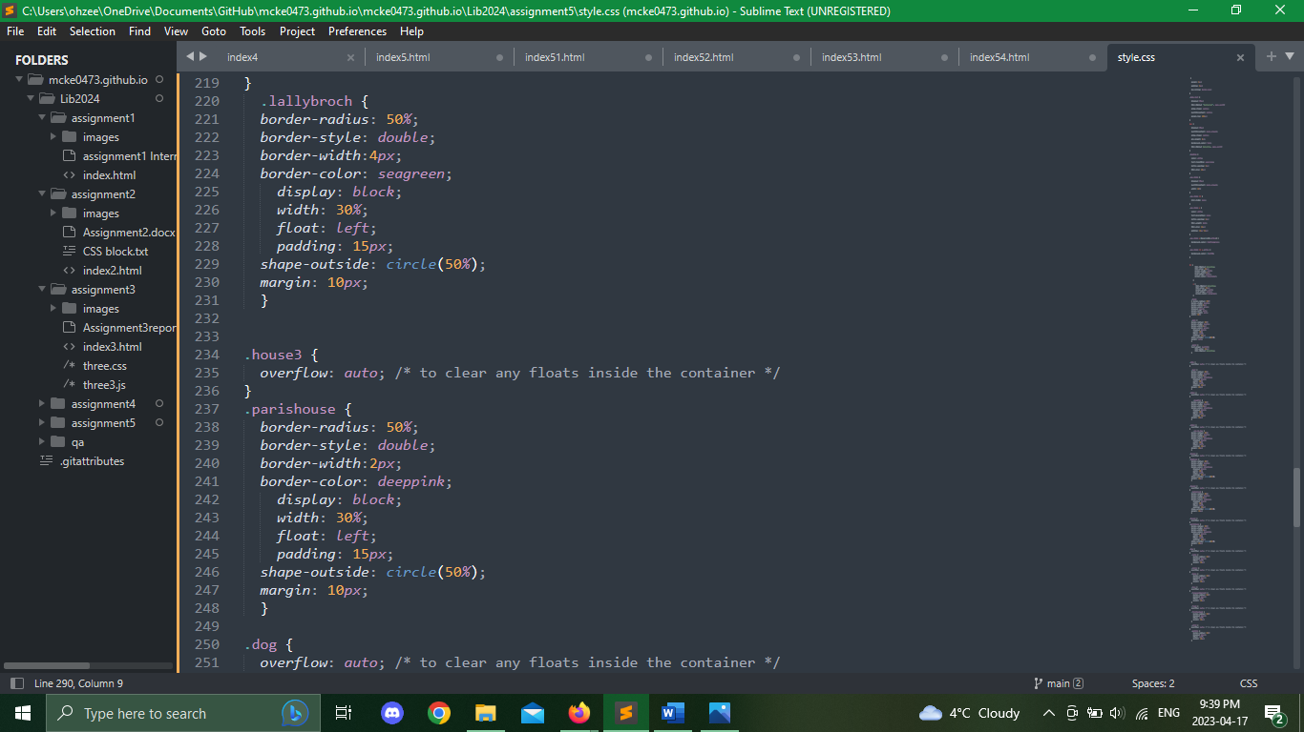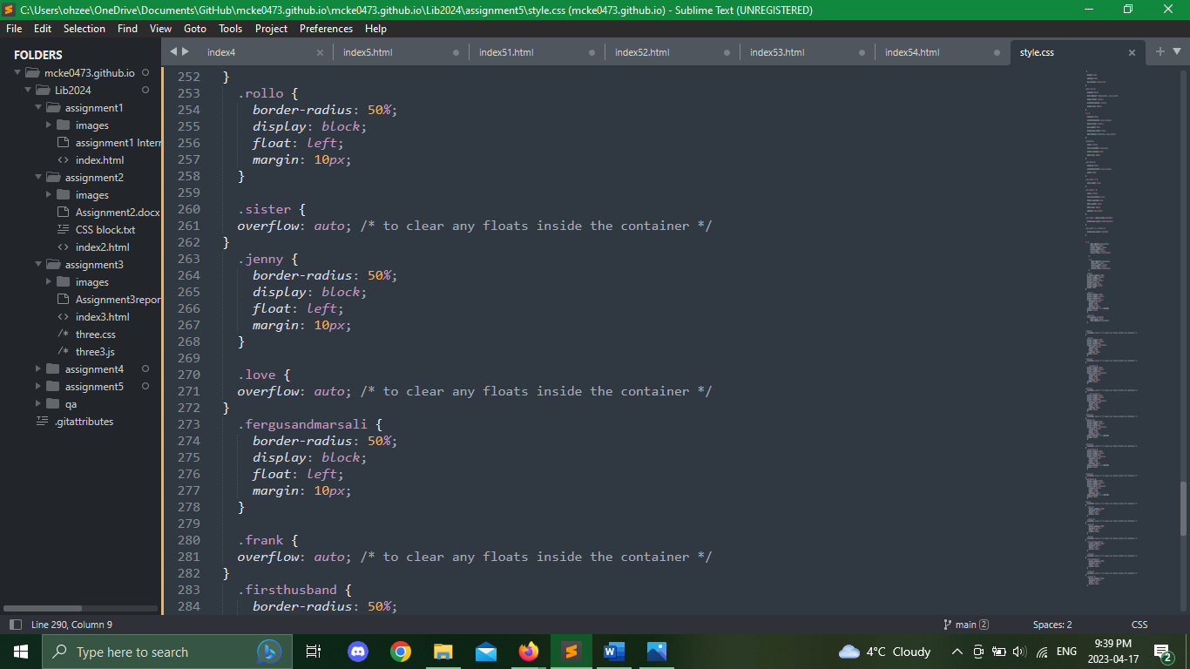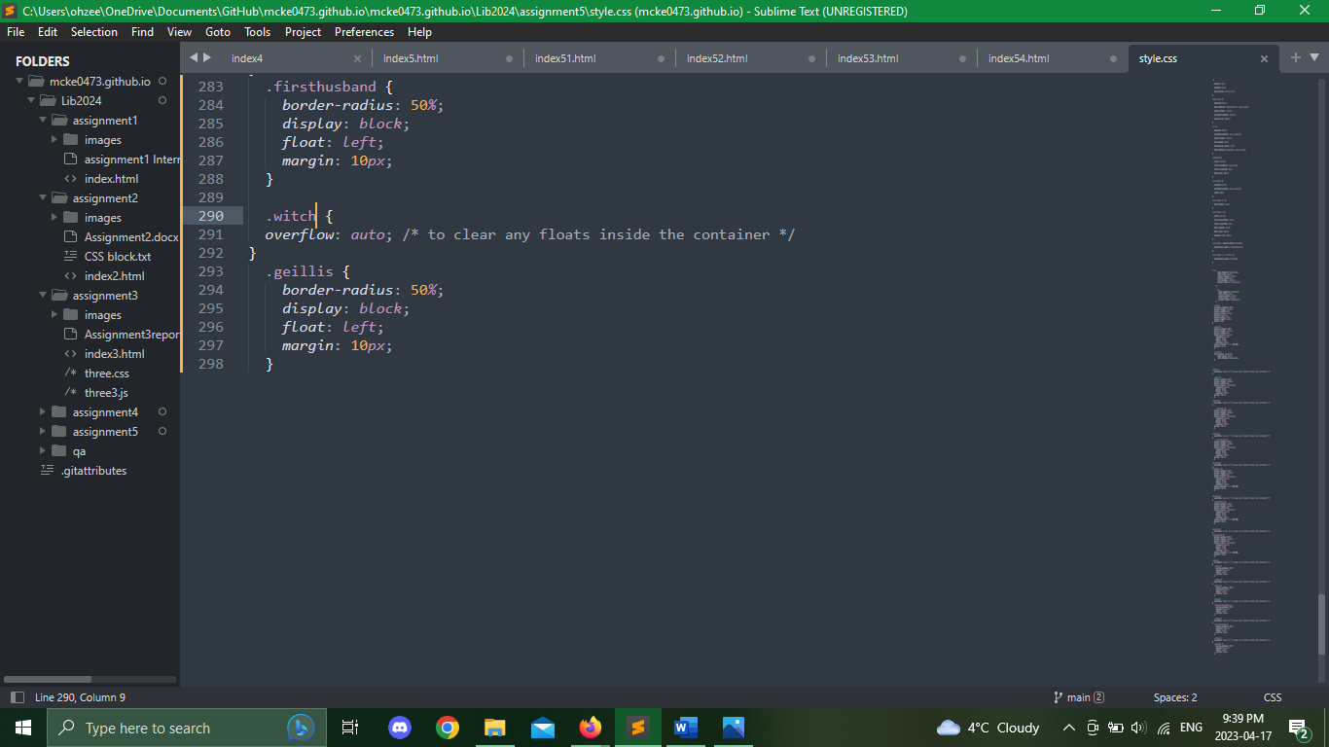

## 

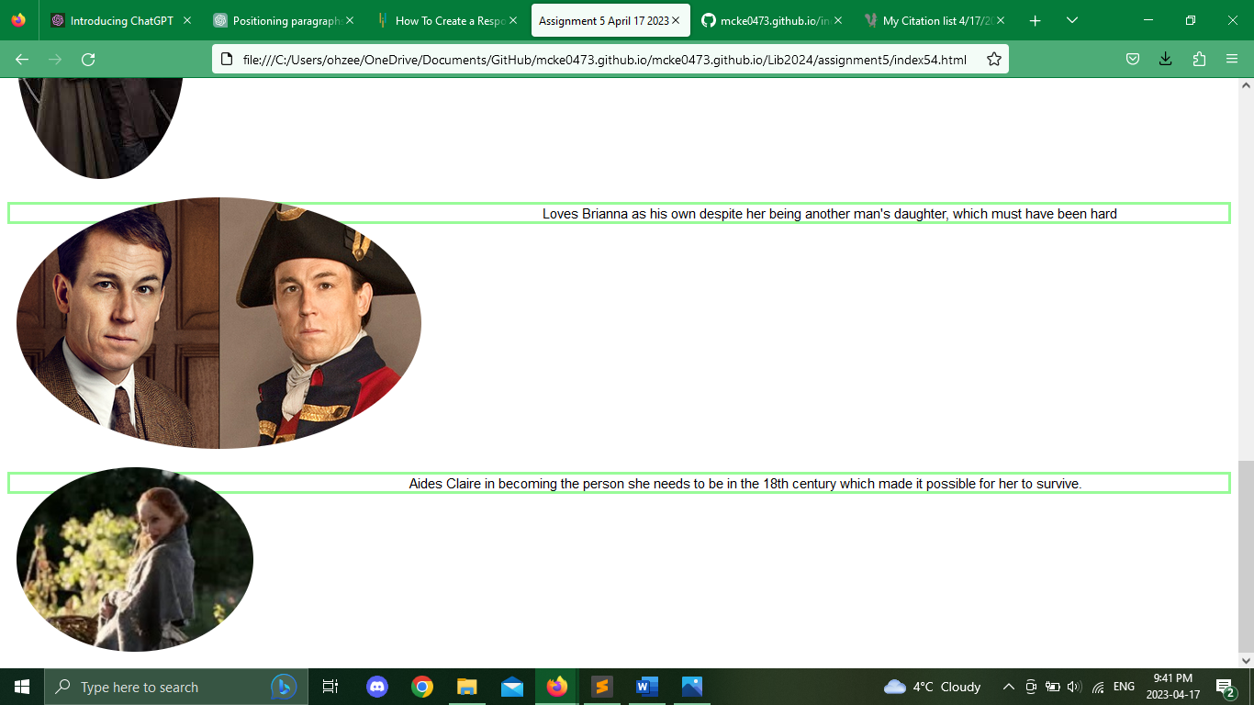

Conclusion

In Conclusion I really enjoyed the challenge of creating a 5-page website, once I got the hang of it, it was easy to control, it was a bit tedious though which made for hard work. Creating a separate CSS file was a huge triumph for this assignment since in previous assignments I couldn’t get it to work. I realized in the making of this website that I only know how to make pictures rounded around the edges which makes them all look unison but its also sort of restricting. I also enjoyed the personal choice aspect, much like other assignments, I love writing what I am passionate about, even if it makes more work for myself.

References

Gabaldon, D. (n.d.). *Dianagabaldon.com*. Diana Gabaldon. Retrieved April 17, 2023, from http://www.dianagabaldon.com/

*HTML Tutorial*, <https://www.w3schools.com/html/>.

Sufiyan, T. (2023, February 8). *How to create a responsive HTML navigation bar?* Simplilearn.com. Retrieved April 17, 2023, from https://www.simplilearn.com/tutorials/html-tutorial/html-navigation-bar

*W3.CSS tutorial*. W3.CSS Home. (n.d.). Retrieved April 17, 2023, from https://www.w3schools.com/w3css/defaulT.asp